**VR Wire Down Storyboard**

**Learning Objectives-**

FSRs and MTs will be required to assess field conditions by:

1. Identifying the different utilities at various locations on Edison structures (i.e. phone, cable TV, etc.)

2. Identifying the various types of Edison construction and recognizing the difference between high and low-voltage lines, cables, and devices

**Storyboard**

FSRs and/or MTs responsibilities/steps: for 911 wire down calls (handled by troubleman), respond within 30 mins. If no troubleman, MFO is sent to keep the scene safe.

1. Make contact with emergency personnel at the location

2. Assess the situation for the proper Edison response

3. Barricade the restricted area with barrier tape and road cones

4. Contact the CCO Dispatch and report the status of the scene. If needed, request a Trouble-man or Damage Assessment for further assessment

**Note**: Though obvious line repairs may be required, MSO Field Work Force is not authorized to request a line crew to the location

5. Make customer contact or leave the door hanger. If Edison is not involved, advise the customer to contact the appropriate utility

6. Standby until qualified crew arrives on the scene

Required Equipment:

• Safety Vest

• Barrier Tape

• Cones

• Emergency Vehicle Light

• Radio

• Doorhangers

**2. Where are mistakes happening in the field? In what situations? Not following process? Environment?** Misidentification of the condition (telecom wire vs. service wire). If is service wire- secondary? Distribution or transmission line? Broken service drop, checking customer panel. Not being prepared for being onsite for long periods. Have necessary PPE in the vehicle. Have backup flashlight! Bring food.Stay on site until cleared. Doc says to go to another call, you have to remain.

Should be a single point of contact each storm, but usually, there are multiple- sups, MFO dispatch, DOC dispatch, Troubleman. Don’t give in to the pressure- know/follow the procedures. You call your sup, have sup track down where wrong info is coming from.

**3. What do students need most practice with? All the steps above? Or certain ones?**

**1. Storm situation (high winds, heavy rain)- no light calls. Unknown condition. Customer calls/ROC sees outage, have to assess once arrive. Tree down on wire, drop,**

**2. Vehicle traffic**

**3. Residence- arrive at neighborhood, all out.**

**4. Public interaction, controlling public challenges**

**Scenario 1- Single residential part light, clear daytime weather conditions. (heat storm)**

**Service drop wires came loose at weatherhead**

**Make customer contact, go back, visibly see wire not connected, not posing immediate hazard, refer back to DOC for TM to correct**

|  |  |  |  |  |
| --- | --- | --- | --- | --- |
| Step | General | Learner Actions/Interactions | On-screen action | Images |
| 1 | Arrive at scene. Inside truck | Click Question icon.  Must select correct choice before getting out of the truck.  Learner needs to know address, reported condition, meter #/partial (last 4 digits) | Narration: You’ve arrived onsite and safely parked. What do you do next? Question popup-  1- Get out of the truck  2- Make sure you have your PPE  3- Notify DOC to let them know you’re arrived. Give address, reported condition (part light callout). | Standard residential neighborhood. Addresses on curb and on house.  Can be similar to VR Meter Spotting neighborhood.  **NEED IMAGES OF SCE TRUCK interior- Dashboard, front seats, back seats.** |
| 2 | Ensure no visible hazards present before exiting vehicle | Question icon.  Must select correct choice before exiting truck. | Question popup-  1- Get out of the truck  2- Make sure you have your PPE  3- Look for any visible hazards. |  |
| 3 | Ensure PPE | High vis vest/shirt, dogstick/protection, “talk to himself, I need my V watch/hard hat”. | Anytime called to storm, should be wearing high vis/hard hat. | CHOOSE PPE Options below. For simplicity sake, 1 shirt, 1 pant.  Need image of V watch, hard hat |
| 4 | Attempt customer contact | Going to door, ring doorbell, doesn’t work. Knock… | Customer (Avatar) opens door. “Go on through right gate.” |  |
| 5 | Walk through gate, see service drop and panel | Question icon.  Must select correct choice before continuing. | Question popup-  Identify wire type:  1. secondary  **2. service drop**  3. transmission.  4. communications | NEED IMAGE OF DETACHED WIRE AT WEATHERHEAD |
| 6 | Advise customer to stay in house. | Question icon.  Must select correct choice before continuing. | Question popup-  What do you do next?  1. Go to truck, get ladder, and fix line  2. Go to truck and contact dispatch.  3. **Advise customer to stay in house.** |  |
| 7 | Contact Dispatch or DOC. | Wire secure, not low enough to touch, not posing a hazard at this time. Refer this one and keep moving. | Do they contact back in truck? Outside truck? Doesn’t matter? |  |
| 8 |  |  |  |  |
| 9 |  |  |  |  |
| 10 |  |  |  |  |
| 11 |  |  |  |  |

**Choose PPE options:**

**Shirt/vest # :**

**Pant # :**

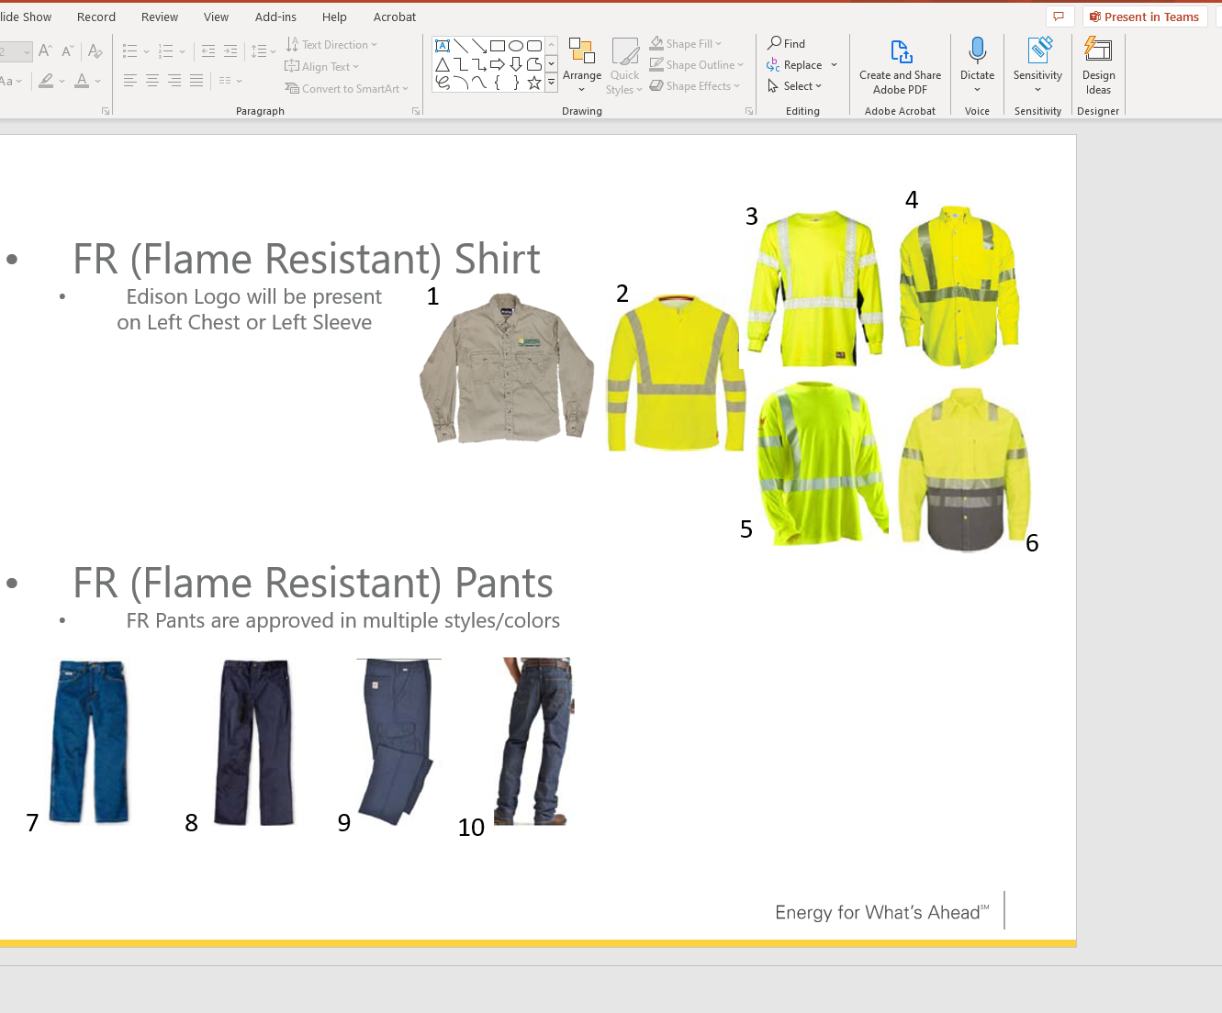

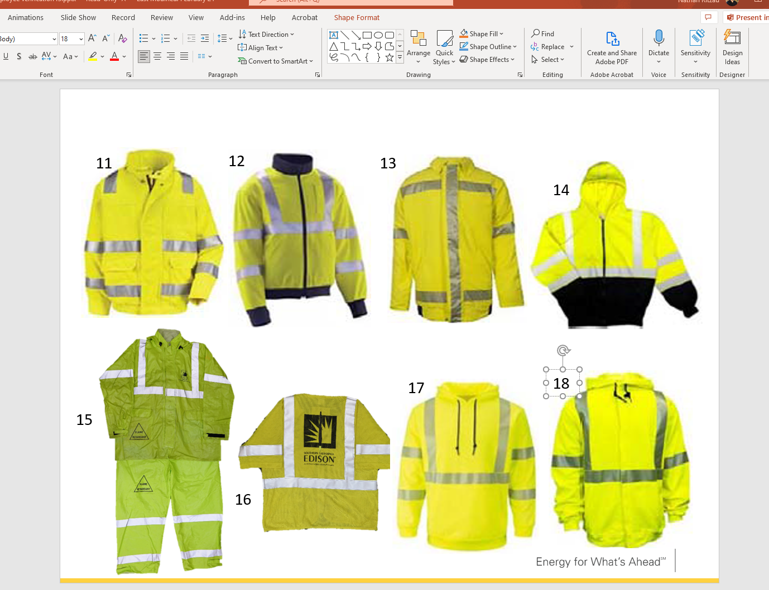

**Scenario 2- daytime wind storm conditions/911 wiredown – vehicle/pedestrian traffic**

**No power in area**

|  |  |  |  |  |
| --- | --- | --- | --- | --- |
| Step | General | Learner Actions/Interactions | On-screen action | Images |
| 1 | Arrive at scene. Inside truck | Click Question icon.  Must select correct choice before getting out of the truck.  Learner needs to know address, reported condition, meter #/partial (last 4 digits) | Narration: You’ve arrived onsite and safely parked. What do you do next? Question popup-  1- Get out of the truck  2- Make sure you have your PPE  3- Notify DOC to let them know you’re arrived. Give address, reported condition (wiredown). | Busy intersection w/ car and pedestrian traffic.  Windy conditions. |
| 2 | Ensure no visible hazards present before exiting | 12kV line in residential area. Pole in parkway. Line hanging on comm line.  Wire down on ground over crosswalk in middle of street. Line hopping/Sparks flying out/little puffs of smoke. | Quiz- transmission, comms, or **distribution.**  Cones need to be set 30 ft away from downed line. |  |
| 3 | Ensure PPE | High vis vest/shirt, | Anytime called to storm, should be wearing high vis. |  |
| 4 | Make contact with public safety guy. | N bound lane  E bound lane  4 way stop | Truck parked in middle of intersection |  |
| 5 | Tape off intersection with public safety guy, set out cones. Establish traffic lanes. |  |  | Civilian on site, need to tape off intersection nearest to wire down.  Need images of cones, tape |
| 6 | Sparking wire stops over time | Traffic control | Bikers, strollers, clueless joggers, ppl walking dogs, ppl wanting to help. Cars moving slowly towards you. You have to direct them appropriately. | Choices pop up when jogger pops up  Ppl wanting to help  One lane of traffic, have to control both sides. Cars back up in one direction, then the other. |
| 7 | Advance 3 hours | On the hour, every hour, calling sup saying no assistance. No ETA, no availability on assistance.  Thinking to himself- exhausted | Questions- must stand by for public safety, just leave the scene. | Skybox turns to dusk/twilight. |
| 8 | Assistance arrived after dark (11pm).  Directing traffic in dark. | Contact made with person arriving, what to expect, once arrived tailboarded, ETA, hazards, status of streets |  |  |
| 9 | Call sup, stayed on site to direct traffic |  | Questions- do you leave? Do you stay? Due to severity of situation, stayed on site until TM arrived. |  |
| 10 |  |  | Once TM arrived, you left. |  |

**Scenario 3- residential, raining, windy, dark, over time winds knocked wire down on grass, dog is electrocuted.**

**No power**

|  |  |  |  |  |
| --- | --- | --- | --- | --- |
| Step | General | Learner Actions/Interactions | On-screen action | Images |
| 1 | Address, reported condition, meter partial |  |  |  |
| 1 | Driving, locating correct address.  No curb addresses. | Once there, let DOC know you’re there before getting out of car. | Notify you’ve arrived on site. | 11921 Maple Avenue correct address.  Neighbor house addresses are 11911 and 11927 |
| 2 | Ensure no visible hazards present before exiting vehicle | Vehicle have spotlight |  | Need image of vehicle spotlight |
| 3 | Ensure PPE | High vis vest/shirt, dogstick/protection, “talk to himself, I need my V watch/hard hat”. | Anytime called to storm, should be wearing high vis. |  |
| 4 | Interact with customer |  | “kept hearing crackling, bright lights” made sure dog chained up in back. |  |
| 5 | Advise customer to stay in house. |  |  |  |
|  | Walking back to yard | Hearing dog barking, getting louder as get closer. Debris on ground, tree branches. Hear arcing getting louder. Line falls, no more dog noise. Transformer fuse blows. Still on cement. |  | Need video/image of transformer fuse blowing. |
| 6 | Assess hazard in backyard |  | Use flashlight. | Need image of flashlight |
|  | Kid/dad want to help dog |  | Choices. |  |
|  |  | Call dispatch, wire down, need assistance. | Great, we have another call. Head to that one. (need to stay) |  |
| 7 |  | Leave when TM shows up. | What’s best option?  Ok to wait out front?  Stay in back?  Help dog. |  |
| 8 |  |  |  |  |
| 9 |  |  |  |  |
| 10 |  |  |  |  |
| 11 |  |  |  |  |

**Scenario 4- What can go wrong, does. Flashlight doesn’t work. Debris have to maneuver.**

**Dark, extreme rain.**

|  |  |  |  |  |
| --- | --- | --- | --- | --- |
| Step | General | Learner Actions/Interactions | On-screen action | Images |
| 1 | Address, reported condition, meter partial |  |  |  |
| 1 | Driving, locating correct address | Once there, let DOC know you’re there before getting out of car. | Notify you’ve arrived on site. |  |
| 2 | Ensure no visible hazards present before exiting |  |  |  |
| 3 | Ensure PPE | High vis vest/shirt, dogstick/protection, “talk to himself, I need my V watch/hard hat”. | Anytime called to storm, should be wearing high vis. |  |
| 4 | Make customer contact |  |  |  |
| 5 | Can’t get through due to debris in way |  | What’s next best step?  Move everything  Attempt access from next door |  |
| 6 | Walk to neighbor house. |  |  |  |
| 7 | Discover line on chain link fence | DO NOT touch fence!  Keep safe distance |  |  |
| 8 |  |  |  | Service drop to house A is down. Line on House A/B. Power on in House B. Gain access to pole House B. |
| 9 | Notify both customers, then call dispatch |  | Question… what do you do next? |  |
| 10 |  |  |  |  |
| 11 |  |  | Question… TM arrives, tailboard, you leave. |  |